**INTRODUCTION**

**Dataset Overview and Features**

The Iris Flower Classification is a well-known problem in machine learning and artificial intelligence. It focuses on classifying iris flowers into three species based on their distinctive features. The dataset, also known as the Fisher's Iris dataset, was introduced by British statistician and biologist Ronald Fisher in 1936. It includes 150 samples of iris flowers, each labeled with one of three species:

1. Iris_setosa

2. Iris_versicolor

3. Iris_virginica

The dataset contains the following features:

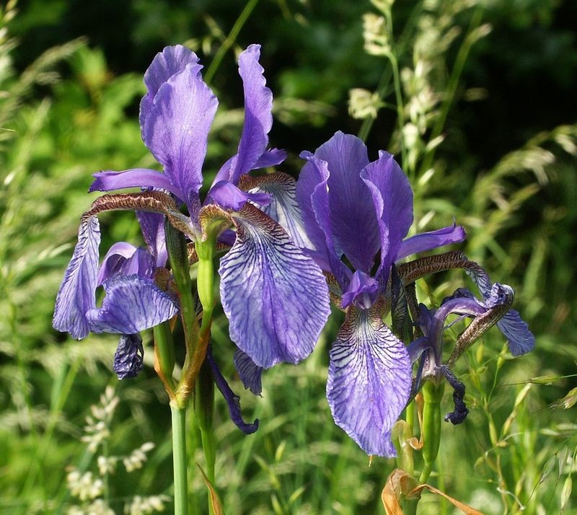

Sepal Length (cm)

Sepal Width (cm)

Petal Length (cm)

Petal Width (cm)

**Model Selection and Training Process**

The main objective of this project is to build a machine learning model that can accurately predict the species of an iris flower based on the given features.

**Steps Involved:**

1.Data Collection:

The dataset used is the Iris dataset, which is publicly available and contains the necessary features for classification.

2. Data Preprocessing:

- Cleaning: Ensuring that the dataset is free from any missing or erroneous values.

- Feature Scaling: Normalizing or standardizing the features to ensure uniformity across different scales.

- Train-Test Split: The data is split into training and testing sets to evaluate the model's performance.

3.Model Selection:

machine learning algorithms were considered for the classification task, including:

- Decision Trees

In this project a Decision Tree Classifier from Scikit-learn was chosen for its simplicity and interpretability. The decision tree algorithm was trained on the dataset to classify the flowers into the three species.

4. Model Training:

The chosen model was trained on the training dataset using the four features (sepal length, sepal width, petal length, petal width) to learn the decision boundaries between the different species.

5. Deployment:

Once the model achieved satisfactory accuracy during testing, it was integrated into a Django web application to allow users to input flower measurements and receive predictions in real time.

**Results and Model Performance**

- Accuracy: The Decision Tree model achieved an accuracy of around 89% on the test set, indicating a strong performance in classifying iris species.

- Confusion Matrix: The confusion matrix highlighted that the model made only a few misclassifications, demonstrating high reliability.

- Cross-Validation: To ensure the model's robustness, cross-validation was performed, and the results confirmed consistent performance across different data splits.

**Insights:**

- Key Features:

Petal length and petal width emerged as the most significant features for classification, which aligns with existing domain knowledge.

- Model Interpretability:

The decision tree structure provides clear insights into the decision-making process, making it a valuable model for educational purposes and research.

**VISUALIZATIONS**

Plot Visualization

The pair plot visualization helps in understanding the relationships between different features and their distributions across the three iris species. This visualization reveals the separability of the species based on the four features.

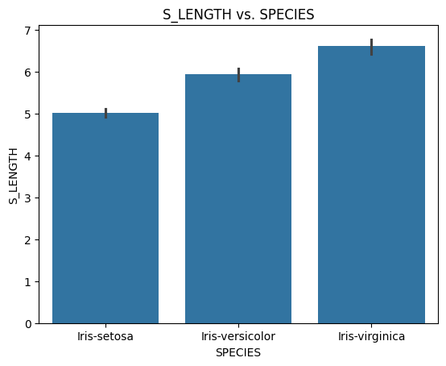 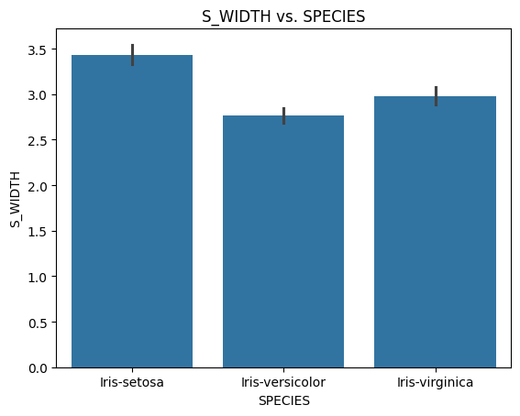

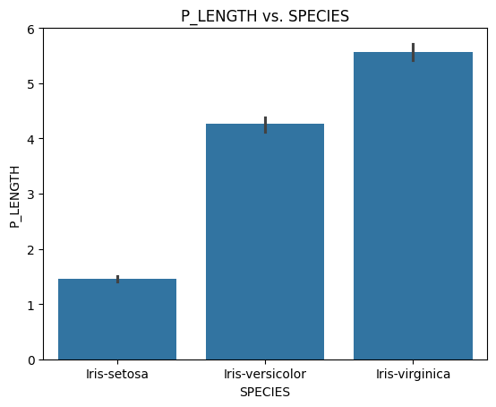 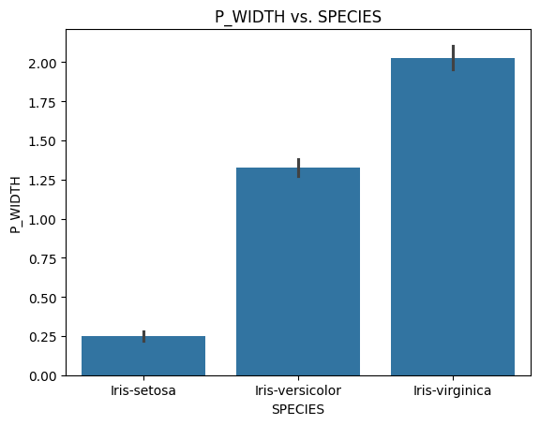

**CONCLUSSION**

**Summary of Findings**

The Iris Flower Classification project successfully demonstrated the use of machine learning algorithms to classify iris species based on flower measurements. The Decision Tree Classifier provided an intuitive and accurate method for solving the problem, achieving high accuracy and offering valuable insights into the importance of specific features.

**Suggested Improvements or Future Work**

1. **Model Optimization:** Consider experimenting with other algorithms such as Random Forests, which can handle overfitting and potentially improve accuracy.

2. **Hyperparameter Tuning**: Further tuning of hyperparameters (e.g., tree depth, minimum samples per split) could optimize the Decision Tree model's performance.

3**. Feature Engineering**: Explore additional features or apply dimensionality reduction techniques like PCA to enhance model performance.

4**. Extend the Application**: Deploy the model in a cloud environment and add an API for programmatic access to predictions.

By enhancing the model and expanding its applications, the Iris Flower Classification can continue to serve as a benchmark for machine learning projects and a foundation for further research in related fields.